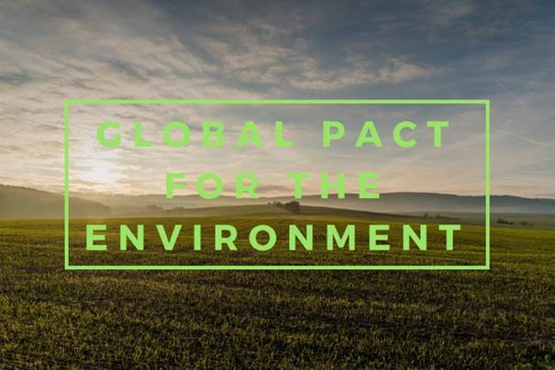

10 DECEMBER 2018 - 1.15-2.30 PM

United Nations Headquarters

Conference Room 11



**STRENGTHENING IMPLEMENTATION OF INTERNATIONAL ENVIRONMENTAL LAW**

**COMMENTARIES ON THE UN SECRETARY GENERAL’S REPORT ON INTERNATONAL ENVIRONMENTAL LAW FOR the “GLOBAL PACT FOR THE ENVIRONMENT”**



On 3 December 2018, the Secretary General’s first report ever on the state of international environmental law was published (A/73/419), providing a technical and evidence-based report identifying and assessing possible gaps in international environmental law and environmental-related instruments with a view toward strengthening their implementation. What findings in this historic report could strengthen the Sustainable Development Goals, while not undermining existing international legal instruments and frameworks and relevant global, regional and sectoral bodies? What general principles of international environmental law support multilateral environmental agreements, for example in light of Intergovernmental Panel on Climate Change’s Special Report “Global Warming 1.5° C” (October 2018)? What synergies exist between environmental agreements and other international regimes? Senior experts will assess the report, prepared pursuant to Res. 72/277 “Global Pact for the Environment.”



**ROY S. LEE**: (Asian African legal consultative organization)

**CLAUDIA DE WINDT** (Senior legal advisor, organization of American States)

**JOHN C. CRUDEN** (former Assistant Attorney General for environment and natural resources to US department of Justice)

**YANN AGUILA** (international group of experts for global pact for the environment and former judge Conseil d’Etat, France)

Discussions will be moderated by **PROF. NICHOLAS A. ROBINSON** (International Council of Environmental Law)

Opening remarks by:

Permanent Representative of France **François DELATTRE** and Deputy Permanent Representative of Senegal **Abdoulaye BARRO**

**RSVP to Lorraine Rubich:** [**lrubich@law.pace.edu**](mailto:lrubich@law.pace.edu) **(+1-914-422-4244)**