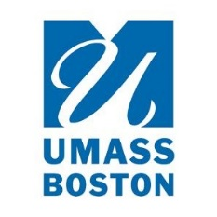
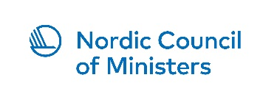

Workshop on International Environmental Governance
and Global Pact for the Environment
29 – 30 November 2018, New York City
Location: Permanent Mission of Finland to the UN, 605 Third Avenue (between 39 and 40 St), 35th Floor
Link to a Zoom meeting: https://umassboston.zoom.us/j/2652767414
Thursday 29 November
Facilitator: David Cash
Dean, McCormack Graduate School of Policy and Global Studies, University of Massachusetts Boston

8.30-9.00 | Coffee / tea
9.00-9.30 | Welcome by Ambassador Kai Sauer and introductions
9.30-10.45 | Session I: What has been done on paragraph 88 in relation to:  - reforming UNEP’s governance structure and in particular establishment of universal membership  - securing stable funding for UNEP  - enhancing the voice of UNEP and its coordination function  - promoting the science-policy interface  - providing capacity-building to countries  - strengthening regional presence and consolidating headquarters functions  - ensuring active stakeholder participation
10.45-11.15 | Coffee / tea
11.15-12.30 | Session II: What has been done on paragraph 89 in relation to:  - enhancing synergies among the Multilateral Environmental Agreements in both the biodiversity and chemicals & waste cluster  - improving the administration of MEAs hosted by UNEP
12.30-13.30 | Lunch  Venue: Mission premises
13.30-15.00 | Session III: Achievements, gaps and challenges
15.30-16.00 | Coffee / tea
16.00-17.00 | Session III: Achievements, gaps and challenges: way forward
18.00 | Dinner  Venue: Amali, 115 E 60th St
Friday 30 November
Facilitator: Maria Ivanova
Associate Professor and Director, Center for Governance and Sustainability, UMass Boston

8.30-9.00 | Coffee / tea
9.00-10.30 | Session IV: Vision for the future of International Environmental Governance in the context of the 2030 Agenda: a Global Pact for the Environment?  - what are key gaps in international environmental law and how could they be addressed  - is there a need for a new instrument, and if so what should be the legal nature
10.30-11.00 | Coffee / tea
11.00-12.30 | Session V: Recommendations for member states, UN Environment and MEAs
12.30-13.30 | Lunch  Venue: Mission premises
13.30-15.30 | Session VI: Elements of a possible resolution on International Environmental Governance for UNEA4
15.30-16.00 | Conclusion

